Дата:06.11.2020
Група №33
Урок №23-24
Тема уроку: «We are afraid of smoking. Control Work.»

Мета уроку:. Ознайомлення з новою лексикою теми, сприяти розвитку в учнів уміння ввічливо висловлювати власні переконання, думки, згоду й незгоду, використовуючи для цього необхідний лексико-граматичні знання. Формування навичок читання та усного мовлення. Провести контроль знань.
Матеріали уроку:
- Перепишіть лексику теми та перекладіть і вивчіть слова.
Smoking, tobacco, cigarette , lungs, cancer, nicotine, breath , emphysema, throat, vision , blood vessels , blood clots, cholesterol , heart disease , diabetes , pregnancy , bronchitis, coughing, irritability, kidneys.

Візуальне супроводження нових слів

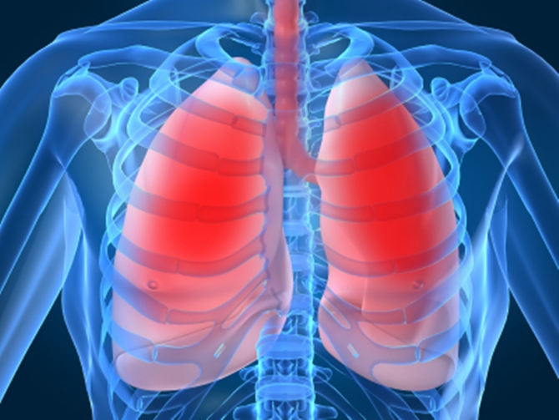 lungs breath

throat 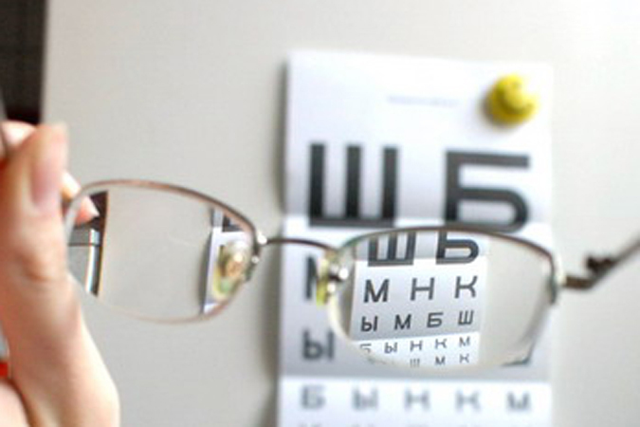 vision

blood vessels 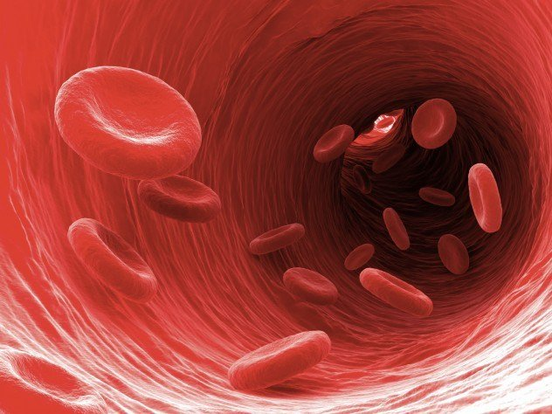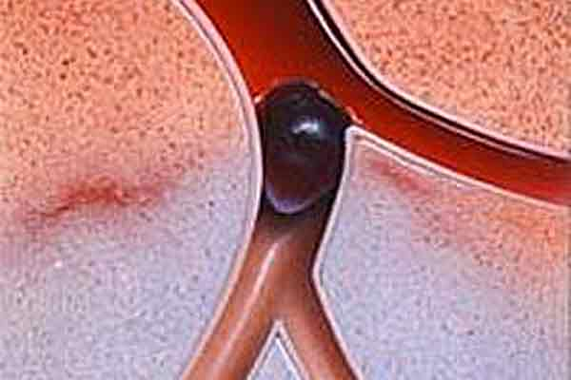blood clots

coughing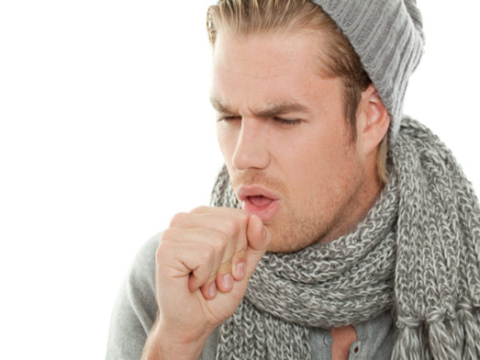 irritability
kidneys 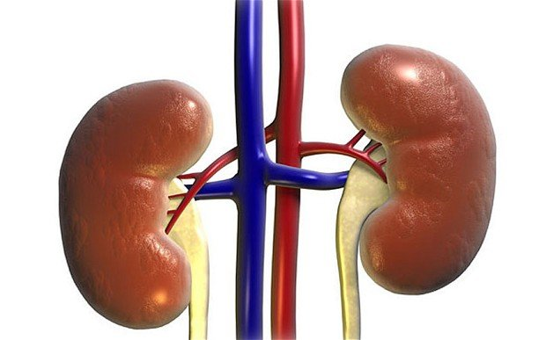

- Прочитайте фрази та перекладіть.
Smoking is a terrible thing.
There’s nothing good about it.
I don’t know how cigarette companies can advertise their products.
Cigarettes kill people.
Smoking is not cool.
Last century, cigarette companies tried to make people think it was.
They even told people that cigarettes were good for your health.
How ridiculous.
Everyone today knows that smoking is one of the least cool things you can do.
Unfortunately, cigarette companies are doing a good job of selling their products to children.
Smoking is on the increase in countries like China and pretty much all over Africa.
This is sad.
Once people get enough information about the dangers of smoking, perhaps millions will quit this terrible habit.

- Перекладіть речення на українську мову.

The Effects of Smoking on the Body
1.Mood stimulation:That surge of energy is due to a nervous system stimulant, which can also make you addicted. If you’re under a lot of stress, it’ll take more to get more
2.Poor vision:Smoking may be the reason you don’t see as well as you used to.
3. Appetite Suppressant:Your sense of smell and sense of taste can be dulled by smoking, which may affect your appetite
4.Irritability and аnxiety:If you missed your cigarette break, or if you’re trying to withdraw, you might find yourself a bit on edge
5.Coughing:All that tobacco smoke can make you cough, but it doesn’t effectively clear your lungs
6.Cold and flu:Smokers experience more colds and flus than nonsmokers do
7.СOPD:Chronic obstructive pulmonary diseases are more common in smokers
8.Lung cancer:Smokers are more likely to develop lung cancer than nonsmokers are.
9.Bronchitis:Smokers aren’t the only ones who have a higher rate of bronchitis. Children of smokers do, too
10.Constricted blood vessels:Nicotine causes blood vessels to tighten and restricts blood flow. That’s bad for your heart and your brain.
11.Too much clotting:Blood clots increase risk of heart damage and stroke
12.High cholesterol:Tobacco smoke steals your good cholesterol and makes it more likely that your bad cholesterol will build up.
13.Blood cancer:Smokers are more likely than nonsmokers to develop cancers of the blood .
14.Heart disease:Smokers and nonsmokers who are regularly exposed to secondhand smoke are at risk of heart attack and heart disease
15.Yellow fingers:Those yellowish fingers and fingernails come from handling tobacco products over many years
16.Stained teeth:Yellowish or brownish stains on the teeth are telltale signs of long-term smoking.
17.Wrinkly skin:All that smoke in your face causes your skin to age prematurely.
18.Smelly hair:Just being around a smoker can make your hair smell of smoke .
19.Diabetes complication:Smokers are at risk of developing type 2 diabetes. Diabetes tends to progress more rapidly in smokers than in nonsmokers .
20.Cancer connection:Smokers have a higher rate of certain cancers, including cancer of the mouth, throat, and kidneys.
Bad teeth:Smokers may develop infection or inflammation of the gums, which can cause tooth decay and tooth loss.
Problems with pregnancy:Smoking during pregnancy can cause a lot of problems for both mother and baby.
Infertility:Male and female smokers are more likely than nonsmokers to have fertility issues
Early menopause:Female smokers tend to enter menopause earlier than nonsmokers
Cervical cancer:Women who smoke raise their likelihood of developing cervical cancer
Problems with newborns:Having a mother who smokes during pregnancy puts a baby at higher risk for health problems
- Поєднайте фрази та їх переклад (цифра-буква)

1. It impairs your vision а) воно викликає задишку

2. It takes your breath away b) це марнування часу та грошей

3. It causes lung cancer and cancer of the throat c) ваші зуби та пальці жовтіють і шкіра
виглядає жахливо

4. It turns your teeth and fingers yellow and gives you ugly skin d) від вас тхне, як від старої
попільниці

5. It makes your breath stink and your hair and clothes smell awful e) воно забруднює повітря та
відштовхує від вас друзів, котрі
не палять
6. It wastes your time and empties your pockets f) воно викликає рак легенів і рак горла

7. It pollutes the air around you and makes your non-smoking friends avoid you g) воно викликає
неприємний запах з рота і ваше волосся та речі жахливо пахнуть

8. It makes you smell like an old ash tray h) воно послаблює ваш зір

5. Сhange the underlined verb into the Future Indefinite Tense:
1.You kill some of the air sacks in your lungs, called alveoli.
2.Many teens like the feeling that smoking gave them.
3.They spend millions of dollars every year on tobacco advertising .
4.Many people realize they are addicted to smoking.
5.They can easily quit of smoking any time they wanted.
6.A lot of people put off quitting smoking.
7.Nicotine absorb quickly into the bloodstream and travelled to the brain.
8.Smoking pregnant women risk the health and lives of their unborn babies.
9.The nicotine, carbon monoxide and other harmful chemicals enter the bloodstream.
10.The smoke contains tar, which is made up of more than 4,000 chemicals.
11.Radioactive particles build up in the lungs and over time can mean a big dose of radiation.
12.Passive smoking happen when non-smokers breathed other people tobacco smoke.
13.The first dose of nicotine cause a person to feel awake and alert.
14.Evidence shows that nicotine has an important role in increasing risk of heart disease.
15.About 80% of adult smokers start smoking when they are 17 or younger.
16.The tobacco industry spends nearly 6 billion annually to develop the market.
17.Each year about 17 million people try to quit for at least day.
18.Menthol cigarette contains enough menthol to produce a cool sensation in the throat.
19.Electronic cigarette allows to quit of harmful habit very easily.
20.The tobacco leaves use in making cigarettes.

6.Напишіть коротке повідомлення про шкоду пасивного куріння (8-10 речень) чи згодні Ви з наступними висловлюваннями та як кинути палити (одне повідомлення на всі висловлювання разом)

Passive smoking is the inhalation of smoke, called second hand smoke or tobacco smoke from tobacco products used by others. Innocent people's lives are put to illness and danger.

Passive smoking worsens the effects of middle ear infections, asthma, bronchitis and pneumonia in children. Protect children. Don't make them breathe cigarette smoke.
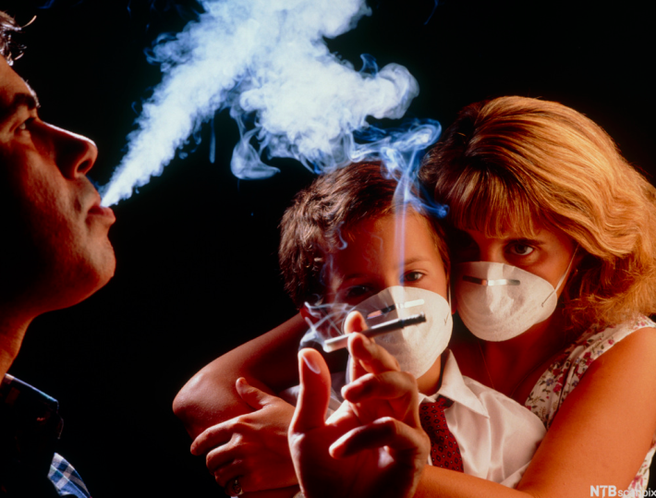

Passive smoking worsens the heart disease , stroke, lung cancer and nasal cancer in adults. She will die from a passive smoking related dіsease in fifteen years time.

Passive smoking kills your dearest one's first. If not for yourself then for your loved one's.

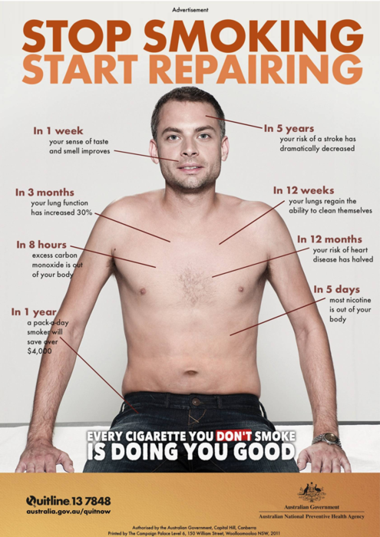

Виконані завдання надсилати: Россоха Н.М- nataross2017@gmail.com
Карнах Е.В.- emiliya.karnakh@gmail.com
Конспекти надсилаємо протягом 2-3 дні з моменту виставлення уроку на сайт училища!!
Учні котрі не надсилають конспекти
взагалі будуть Н/А !!!

