Дата: 03.11.2021
Група №21
Урок № 3-4
Тема уроку: «On the map of the United Kingdom.
The climate of Great Britain. Past Tences.»

Мета уроку: Активізація нової лексики теми. Вдосконалювати навички усного мовлення та письма. Розвивати культуру спілкування та мовленнєву реакцію учнів.
Матеріали уроку:
Запишіть в зошит: Wednesday, the third of November.
Class Work.
Lesson #3-4
Topic: «On the map of the United Kingdom.
The climate of Great Britain. Past Tenses.»

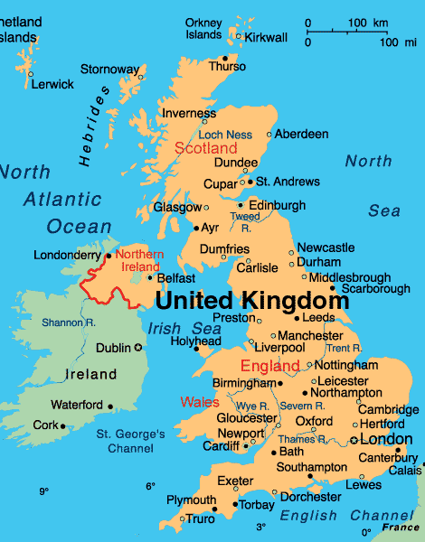
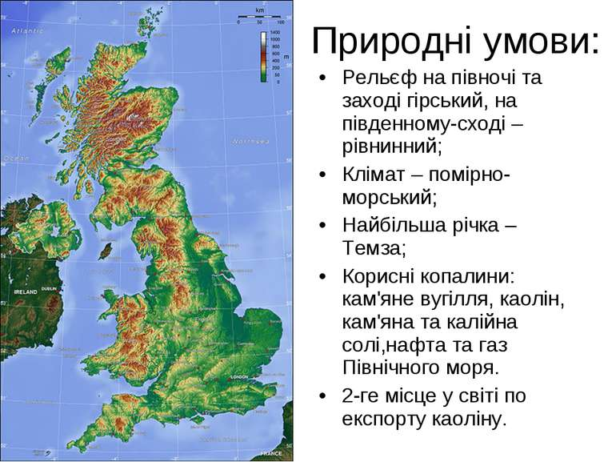
- Прочитайте текст, перекладіть усно. Випишіть з тексту речення в яких описується погода влітку, взимку, восени, навесні.
The Climate of Great Britain
In Great Britain it is never too hot or too cold for work or play in the open air. The sea keeps the island warm in winter.
The winds have also very much to do with weather in Great Britain. Winds from the Atlantic are wet and warm. They bring plenty of rain to the island. The east and north-east Winds are cold and dry.
Thanks to the mild climate there are a lot of evergreen plants in Great Britain. But the lack of sunshine is the reason why the cultivation of grain crops is difficult. Grass grows all the year round.
The weather changes very often. In spring sunshine and showers follow each other often during the day.
In spring the weather is generally mild, the summer is not so hot as on the continent.
In winter sometimes it rains and sometimes it snows, and they also have fog and frost. The rivers and lakes are seldom covered with ice.
But the worst thing about the climate in Great Britain is the thick fog they so often have in autumn or winter.
- Повторити лексику та скласти речення або словосполучення з даними словами стосовно теми уроку та записати у зошит..
Parliament, parliamentary democracy, monarchy, constitutional monarchy, power, branches of power, legislative, executive, judicial, president, presidential republic, the Supreme court, the government, the Prime minister, the Congress, the House of Lords, the House of Commons, to elect, to vote, to appoint, to rule, a bill, a law, to delay, to pass, to challenge, to approve.
- Виконайте вправу письмово з опорою на граматичну таблицю.
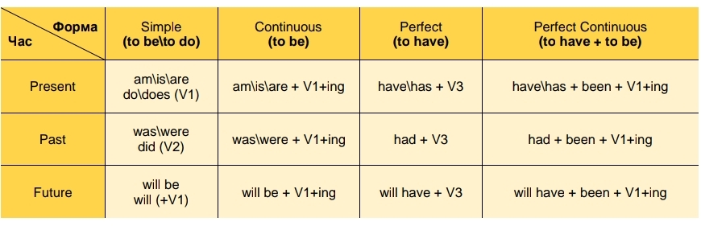
- Last month I (go) to Scotland on holiday.
- It (be) awesome movie!
- I (visit) lots of museums. I (be) with friend of mine .
- In the evening we (meet) him.
- In the morning I (get) up early.
- The weather (be) fine yesterday.
- It (be not) cheap.
- We (see) some beautiful rainbows.
- Where (spend / she) her last holiday?
- When she phoned her father, he (watch) TV.
- Yesterday at seven my mother (prepare) dinner.
- The children (play) in the garden when it suddenly began to rain.
- I (practice) the playing piano when my girlfriend came home.
- They (not / cycle) all day.
- While Mike (work) at his project, his friends (play) football.
- I tried to tell her the truth but she (not / listen ) .
- What (he/ do) yesterday at 5 o’clock?
- Most of the time we (sit) in the nearest park.

Домашнє завдання.
Записуємо в зошит:
Wednesday, the third of November.
Home Work.
- Довчити лексику із завдання 1 і 2.
- Повторити правила вживання минулих часових форм дієслова.
- Виконати письмово вправу.
- I lost the key that he (give) to me.
- She told me that she (see) the film .
- I went outside as I (hear) a noise.
- She picked out the red dress, which she (not / wear) for ages.
- Mike (not / swim) in the beach before that day.
- His father was angry because he (not / help) him.
- (you / have) dinner before you left the house?
- (he / manage) to find a place to stay when he went to Paris?
- Where (she / stay) before she moved to live with her boyfriend?

- I (try) to get tickets for that play for months before my friend finally got them.
- When I arrived at the theater, my friend (pick, already) up the tickets.
- He was really angry because he (wait) for more than half an hour when I arrived.
- When the play started, I (already, apologize) to my friend.
- We (watch) the play when the lights went off.

Виконані завдання надсилати: Россоха Н.М- nataross2017@gmail.com
Карнах Е.В.- emiliya.karnakh@gmail.com

