Дата: 30.03.2022
Група №33
Урок №16
Тема уроку: «TYPES OF MICROPHONES»

Мета уроку: Ознайомлення з новою лексикою теми, сприяти розвитку навичок читання та письма, використовуючи для цього необхідний лексико-граматичні знання з професійної тематики. Вдосконалення навичок усного мовлення.
Матеріали уроку:
The proximity effect is a phenomenon that leads to an increase in low frequency response as you move the mic closer to the source. The closer you get, the bigger the bass boost is. This can create problems, but at the same time, it opens up ways to shape the sound.Some microphones allow to switch between different frequency response ranges.
Polar Pattern or Pickup Pattern define show microphone responds to sound from different directions. This is important when you choose a microphone for a specific purpose. The most common patterns are:
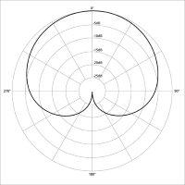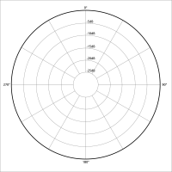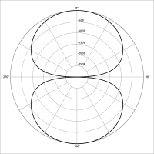Omnidirectional
A commonly used microphone design, able to pick up sound from a 360 degree radius.Perfect for interviews, moving subjects.

Bi-Directional
This polar pattern only picks up sound waves from the front and the back of the microphone, all sounds coming in from the sides won’t be heard or will be distorted. Perfect for podcasts, radio interviews.
Cardioid
This polar pattern is used for live broadcasting or for singer’s performances on stage because the sound waves can only be picked up from the front, so the audience’s noise does not affect the quality of the sound coming from the microphone.Perfect for documentary recording, weddings, events.

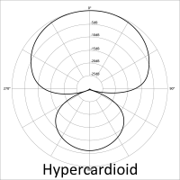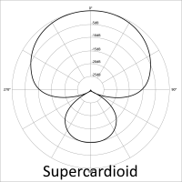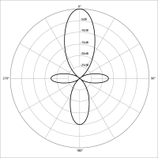Hyper-Cardioid
Much like the cardioid but due to having the small back sound pickup it produces a better sound because it has the all-round frequency response. Perfect for on-camera mics, documentary recording, and instrument recording.
Supercardioid (Shotgun)
Supercardioid mics are the most popular types of microphones for indie filmmakers because they give users the ability to isolate audio. Perfect for: reality television, movie making.

Lobar (Unidirectional)
A lobar pattern is the most directional pickup pattern you can use but it is hard to work with. Perfect for narrative film, controlled sets.

Other microphone specifications are:
Output impedance: used to determine what transformer is necessary to transfer the power efficiently from microphone.
Sampling rate: the more the better. The minimum standard sampling rate is 44.1 kHz. Highsampling rate sounds crisp and rich while lowsampling rate soundsmuffled and low quality.
Bit Depth: again, the more the number the more dynamic your sound will be. The standard numbers are 16 bit or 24 bit.
Audio interface: USB, 3.5 mm or XLR
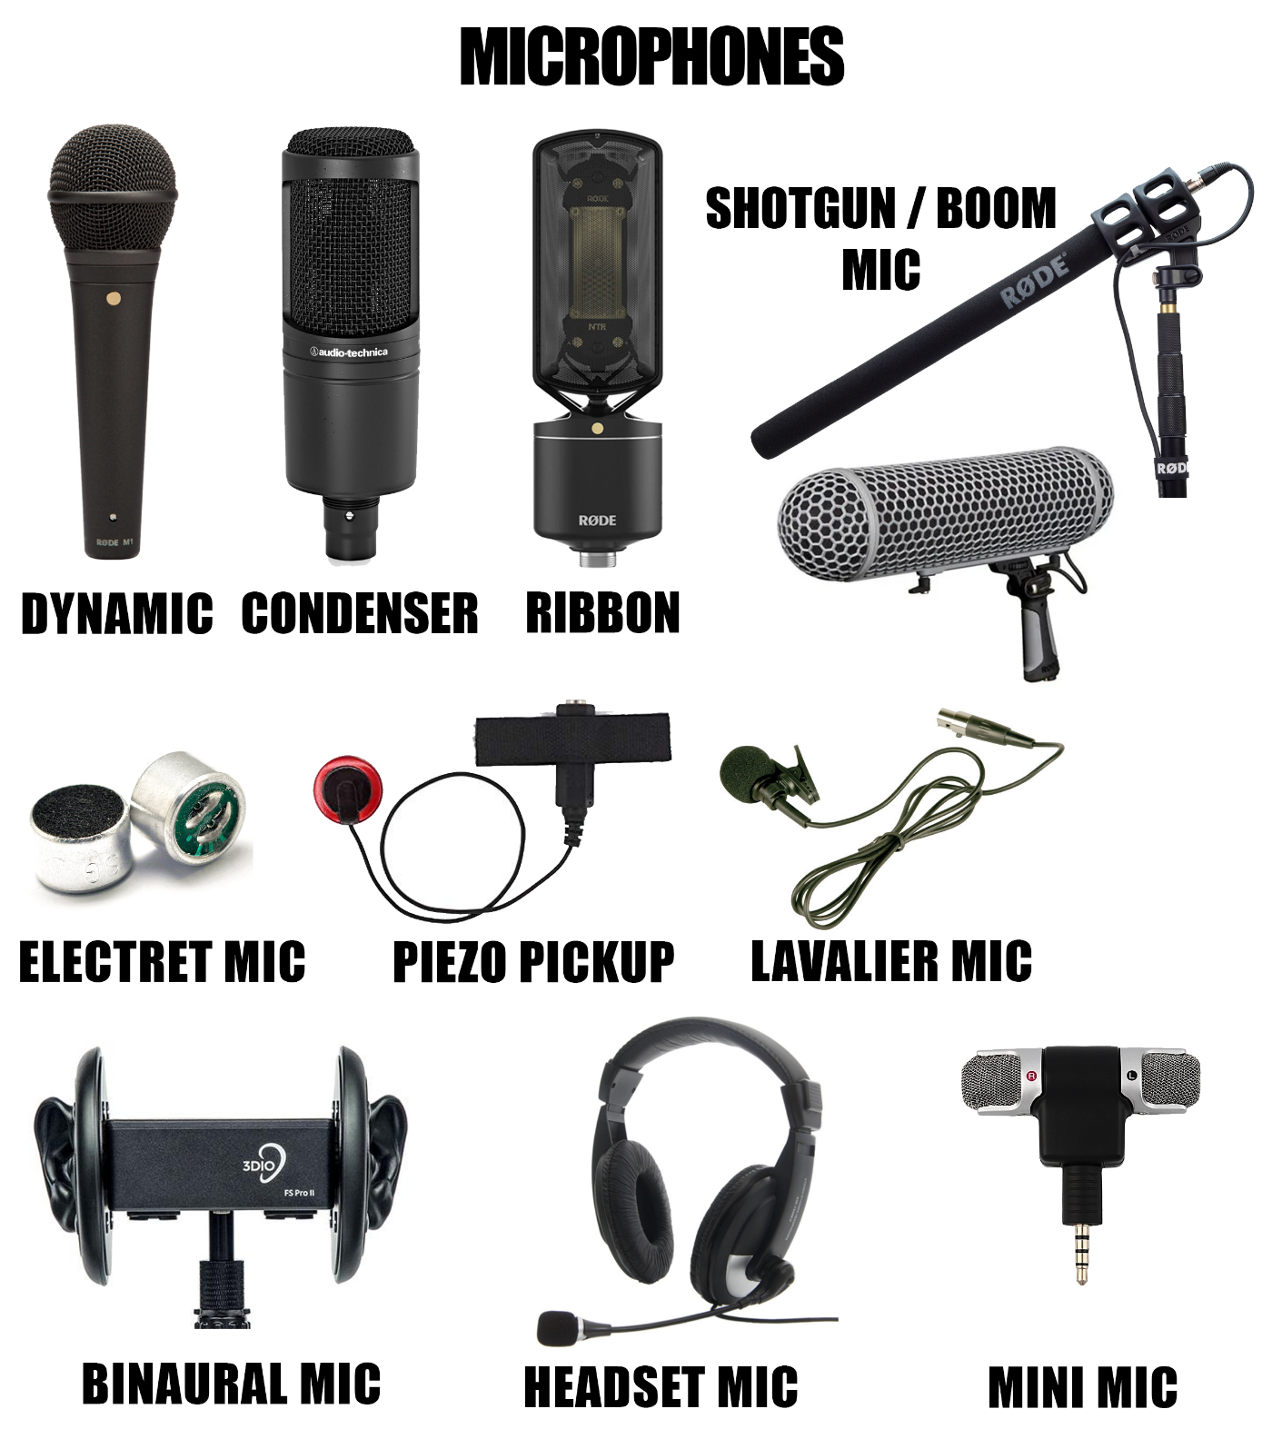
A lavalier microphone (also known as a lav, lapel mic, clip mic, body mic, collar mic, neck mic or personal mic) is a small microphone used for television, theatre, and public speaking applications in order to allow for hands-free operation. They are most commonly provided with small clips for attaching to collars, ties, or other clothing. The cord may be hidden by clothes and either run to a radio frequency transmitter kept in a pocket or clipped to a belt, or routed directly to the mixer or a recording device
A binaural microphone is used for recording audio that sounds really close to what we hear in real life. That kind of sound is currently used for ASMR (Autonomous Sensory Meridian Response)recordings and video games to increase the immersion and create a certain mood or atmosphere.
A headset microphone is usually used for voice communication services.
A mini mic is used as an alternative for ordinary microphones when you need something portable. The sound quality is usually low. You can connect it to your camera or laptop.
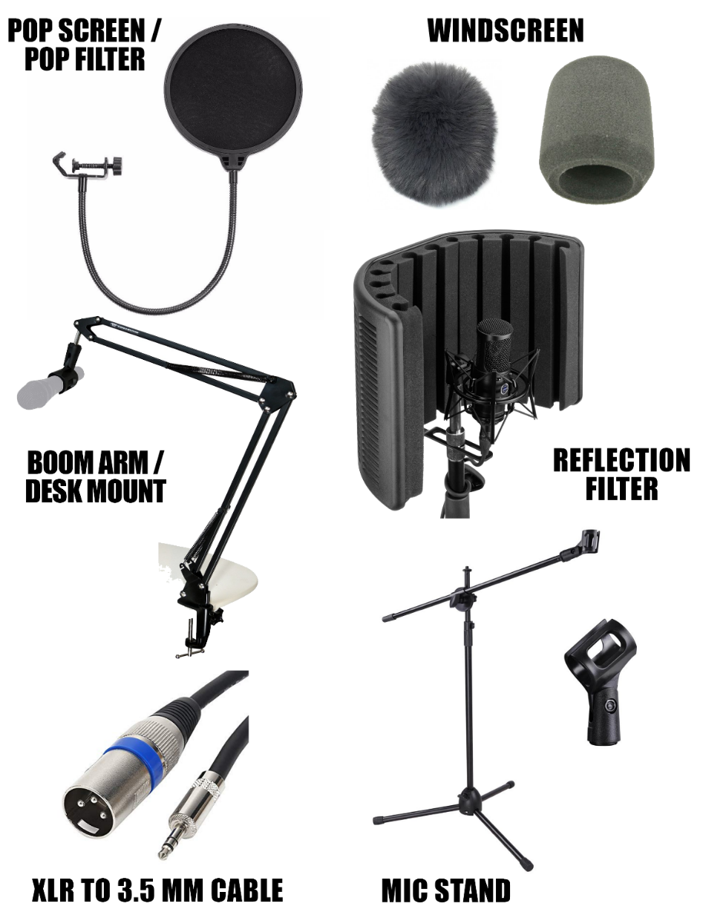
The last but not the least, are some of the microphone accessories:

Do the tasks:
- Read and translate the text.
- What is the proximity effect?
- Describe the work of the other kinds of microphones.
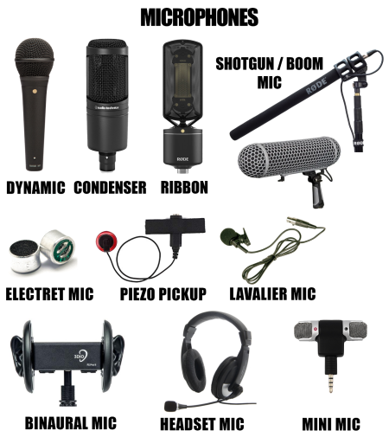
- When and how do we use the microphones from the pre last picture of the lesson?

Конспект уроку надсилати на е-пошту викладача: nataross2017@gmail.com

