Дата: 12.04.2022
Група №33
Урок №24
Тема уроку: «APPLICATION PROGRAMS»

Мета уроку: Ознайомлення з новою лексикою теми, сприяти розвитку навичок читання та письма, використовуючи для цього необхідний лексико-граматичні знання з професійної тематики. Вдосконалення навичок усного мовлення.
Матеріали уроку:
Application software (app for short) is software designed to perform a group of coordinated functions, tasks, or activities for the benefit of the user. Examples of an application include a word processor, a spreadsheet editor, an accounting application, a web browser, an email client, a media player, a file viewer, a console game, a presentation program or a photo editor.
Usually, they have similar window interface. The top part of a window contains a set of drop-down menus like File, Edit, View, Preferences or Settings and Help. 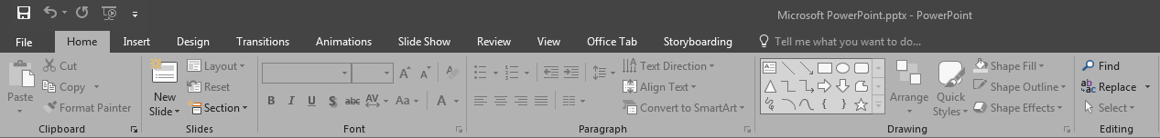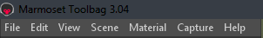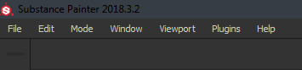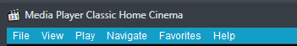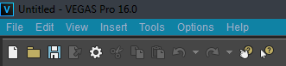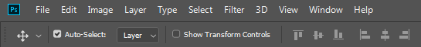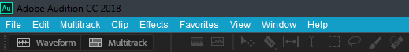These menus might look different depending on what application is used for. Here are a few examples of different program menus.

Each program only works with certain file formats. As a rule, each file name ends with a dot and a few letters which are short names for formats (you might need to enable file extension display in your folder settings to see them). For example, MP3, MIDI, MPEG, DVD, AVI or WAV files can be opened in a media player but they are not compatible with an image editor.The best thing to do would be reading forums, manuals or watching tutorial videos to learn more about programs and their interface functions.
Do the control tasks:
Questions
- What is an operating system?
- What are the main graphical elements of Windows OS?
- What are the main file system formats?
- How do you install or uninstall a program?
- What are the application programs?
- What menus can be found in application programs?
- What application programs are designed to do?
- Can you describe the general steps for Windows installation process?
What are application programs?

Exercise 2
Fill in the gaps
1.To go to Control Panel, you should press the _______ _______ in the bottom left corner of your ________.
2. You can find your images in “My pictures” _________.
3. To ______ a program, double click its icon.
4. NTFS, FAT32 and exFAT are the ___________ used in Windows.
5. You can divide your hard drive space in parts called __________.
6. Programs designer for specific tasks are called _________ ________.
7. The top part of these programs contains a set of _____-_____ _______.
8. Each program only works with certain _______ _______.

Exercise 3
Write a dialogue for one of the topics:
- Try to briefly explain your partner the general steps for installing Windows.
- Your partner doesn’t know how to uninstall a program. Try to give him or her a step-by step instruction on what to do.

Конспект уроку надсилати на е-пошту викладача: nataross2017@gmail.com

